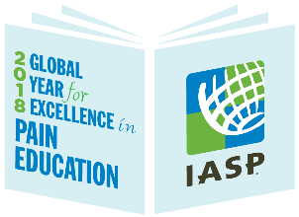
Learn about the 2018 IASP Global Year for Excellence in Pain Education

